ONA 55 Newsletter | 
August 2025

Quick updates
Temperatures run high literally and metaphorically. We have been receiving many emails or in person questions on the new Central Contract and are we getting a raise? The answer is hopefully soon! The arbitration award from Sheri Price, an arbitrator in labour law has to review many documents one very lengthy document is on nurse to patient ratios! She is working evenings and weekends to deliver a timely decision from a very lengthly 4 day hearing on April 2&3, April 14 and 17^{th.} If you have any question for the Hospital Provincial Negotiation Team reach out to Erin Ariss at president@ona.org. Ona delivered a very educated witness on the topic of nurse patient ratios. Which can lead to better patient outcomes, retention of nurses and decrease nursing burnout. California, Australia,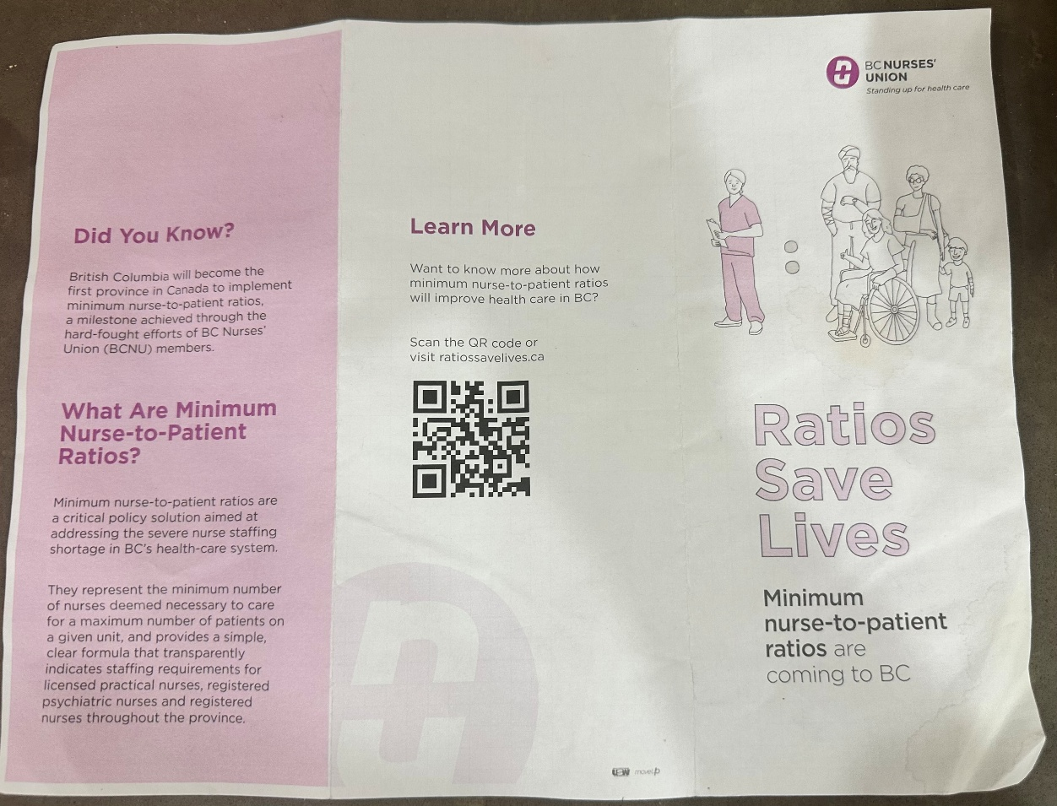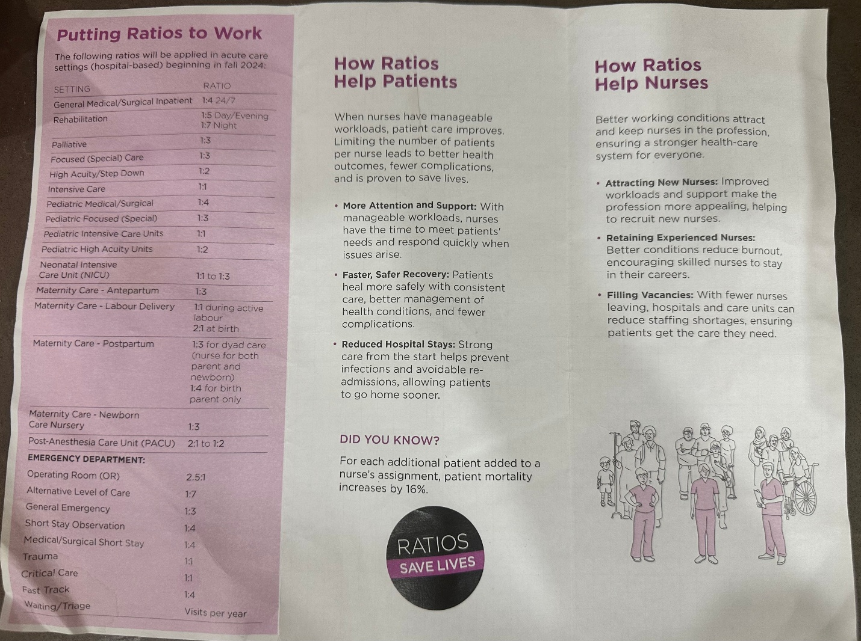 New Zealand are some countries that instilled in their contracts appropriate nurse patient ratios. See the website from BC on appropriate nurse patient ratios and how your unit should be instituting these appropriate ratios Minimum Nurse-to-Patient Ratios | BC Nurses' Union. Canadian Nursing Federation of Unions also is a great resource to reference in your workloads. Nurse-Patient Ratios Canadian Federation of Nurses UnionsCanadian Federation of Nurses Unions

There is a new platform to have your say in the revamp of the magazine “Front Lines” Has changed to “F-Word” see webpage if you want to write a story of your nursing fears or fantastic events that occurred F-Word · The Ontario Nurses' Association Magazine

When our team members went to CFNU we also received this pamphlet from BC. See above.
Our next conference will be in Toronto, called Biennial where some members have been selected to go with the executive team to see how ONA operates and amends constitutional amendments and speaks to provincial case law. Case law changes our central contract articles for example 14.06 which I spoke to above. The more times ONA or Hospital win in arbitration this dictates how the interpretation of the article can change. We hope that the members selected will enjoy their time. Human rights and equity will also be discussed on the first day of Biennial and those worker reps will be attending on Monday November 3, 2025. Good luck to the reps and BUPs, VPs etc who will be in attendance for this informative conference on Human Rights! See below for more save the dates Meetings.
 | Date: |  | Time: |  | Facilitator:
 | October 9, 2025 |  | 1930-2030h |  | Michelle Kumbera

Where |  | aGENDA
TEAMS for all ONA 55 Members! Discussing Constitutional Amendments, meaning how ONA central and Locals operate and govern the Collective Agreement and other positions, education, etc.
fOR cambridge memorial hospital

Date: |  | Time: |  | Facilitator:
October 9, 2025 |  | 1130-1300h |  | Michelle Kumbera BUP and Diego Marquez VP

Where |  | aGENDA
Cambridge Memorial Hospital, Virtual and in-person Room A.4.106  With Pizza and light snacks and drinks provided. |  | Discussing Constitutional Amendments, meaning how ONA central and Locals operate and govern the Collective Agreement and other positions, education, etc.  We will also combine and discuss our Local Contract and trendings we have noticed in workloads and grievances and new business can be brought up her from the members.

gRIEVANCE tRENDINGS
We have noticed that there are two main trendings. One being the consecutive call back article, under article 14.06.
14.06
Where a full-time or regular part-time nurse has completed their regularly scheduled tour and left the hospital and is called in to work outside their regularly scheduled working hours, or where a nurse is called back from standby, such nurse shall receive two (2) times their regular straight time hourly rate for all hours worked with a minimum guarantee of four (4) hours' pay at two (2) times their regular straight time hourly rate except to the extent that such four (4) hour period overlaps or extends into their regularly scheduled shift. In such a case, the nurse will receive time two (2) times their regular straight time hourly rate for actual hours worked up to the commencement of their regular shift.
We had grievances that members would be paid after consecutive night shifts the call back portion of 14.06. Unfortunately, with grievances that go to arbitration this practice is no longer being honoured for ONA members as Employers in arbitration have now changed this practice provincially. The “Regularly Scheduled” tours meaning you needed to be scheduled that night shift for example on August 18 and then an ANDGO alert is posted after you finished your shift August 19 at 0700h for another night shift for August 19TH This will be a 14.06 double time shift. Now you are off shift at 0700h August 20 and another ANDGO alert is out for another night shift. Employer will say that your August 19 was not a “Regular Scheduled Shift” it was already at premium for double time and now you’ll only receive time and a half for the full timer or straight for a part timer not in excess of 75hours.
The second trending of our 14.06 article is an ANDGO shift that has been out for a while meaning in my last example of August 19TH you finish your night shift at 0700h and the ANDGO for nights August 19th at 1900h was published on August 13, 2025 at 1400h does not mean you would be in call back position either as the shift for ANDGO needs to be published preferably the time you ended your scheduled shift for this example at 0700h on August 19TH.
If there are any questions about the above questions on 14.06 please do not hesitate to email Diego and myself as we would be happy to answer for you!

Budget, SICK TIME AND INVERSE RELATIONSHIP TO pATIENT rATIOS and nurse burnout
The employer will speak to their budget and sick time being ultimately high. Our colleagues were fortunate to go to CFNU. Stating to your employer that you understand their challenges with the staffing shortage. Statistics state that Canada’s nurse to patient ratio is 10.3 per 1000 and it exceeds the average slightly of 9.2. 64% of Canadian RNs work full time compared to 82% in the U.S. reducing total care hours (Canadian Nurses Association, 2025). Absenteeism is higher averaging 19 days per year in Canada vs 7 days in the UK. There are only a few factors that hamper the productivity of Canadian Nurses. (Villeneuve, 2024, p.23)
Ontario in a survey conducted in 2024 reported that 34% of RNs reported an inappropriate skill mix for patient acuity. Budget affects workload and professional issues as well as paid and unpaid overtime that result in rising injuries and burnout. (Berry & Curry, 2012 p. 50)
In March 2025 there was a national nurses survey that addressed topics of work experience and quality care, well-being, Intention to leave, Preceptorships, Federal patient bill of rights, health, safety, & Discrimination, Experiences of Early Career Nurses, Experiences of Internationally Educated Nurses, in a 65 page document that is worth a read and may be beneficial in employer conversations. (Canadian Federation of Nurses Unions, 2025, March).

Raffle winners
From our Nursing week raffle baskets from the May Newsletter. Here are our 5 winners!
- Avery Jack ICU
- Edward Rabera Med B
- Jerilyn Fisher SCN
- Jessica Sonnenburg LD
- Christine Donaghey MDC

New business |  | SAVE THE DATE
- See the 2025 March National Nurses Survey see References for Link  - F-WORD Magazine F-Word · The Ontario Nurses' Association Magazine  - Arbitration Updates on https://ona.org/bargaining-updates/ |  | - Constitutional Amendments on October 9, 2025 at 1930h for all of ONA 55 Members to attend.  - ONA 55 CMH members may attend in person on Oct 9 for our second Bargaining Unit meeting and discussion of Constitutional Amendments from 1130-1300h

References
Berry, L., & Curry, P. (2012). Nursing Workload and Patient Care. Canadian Federation of Nurses Unions (CFNU). Retrieved August 14, 2025 from https://nursesunions.ca/wp-content/uploads/2017/cfnu_workload_printed_version_pdf.pdf
Canadian Federation of Nurses Union (CFNU). (2025, March). CFNU National Nurses Survey. Retrieved August 14, 2025 from https://nursesunions.ca/wp-content/uploads/2025/03/cfnu-member-survey-report_March-25_final-65.pdf
Canadian Nurses Association. (2025). Nursing Statistics. Retrieved from https://www/cna-aiic.ca/en/nursing/regulated-nursing-in-canada/nursing-statistics#:~text=employementstatusofnursesinemployedonacasualbasis
Villeneuve, M.J. (2024). Redefining nurse staffing to revolutionize health care in Canada: Snapshot of the first national Nurse-patient Ratios Summit 2024. Canadian Federation of Nurses Unions (CFNU). Retrieved August 14, 2025 from https://canadacommons.ca/artifacts/21648496/redefining-nurse-staffing/22548685

Next meeting
13 October 2023| 6:00 p.m. in the cafeteria
Motion to adjourn was made at 9:00 p.m. and was passed unanimously.

